TRAVEL FORUM
A members’ service of the Membership Services Committee
Columbia River Chapter, MOAA
The Travel Forum is an information exchange to share advice, cautions, lessons learned, recommendations, and information about travel U.S. and international travel. The Columbia River Chapter has not validated and does not promote or endorse any web sites or references provided by travel forum members. The information is included solely as suggestions, with appropriate caution, for the participant’s own research.

CURRENT TRAVEL ENVIRONMENT

- The pent-up demand to travel in the post-pandemic period has not lessened through the summer and early autumn of 2023. The forecast for 2024 is:
  - Continued high volume of travelers despite increasing costs for transportation, lodging, and food.
  - Airline and car rentals’ costs will remain relatively high with cruise lines also affected by higher fuel costs.
  - Travel delays and disruptions will continue with customer service and support still suffering from staff shortfalls and inexperience.
  - Tours, cruises, State and Provincial Parks military facilities, and other reservations, particularly for rate discounts, will continue to fill up faster than the pre-pandemic period—you should start making reservations now during October and November for late spring and early summer of 2024 for popular international travel destinations and events.
- With longer lead times, review the travel tips throughout the past Travel Forums posted on the Chapter’s website for how to better recover your pre-paid travel costs if a change in plans occurs.
- Recent travel experiences during holiday and peak travel times (i.e., May-September) include:
  - Longer than usual security check lines—plan to arrive at the airport earlier than you have planned in the past.
  - Social distancing and masks are rarely practiced despite the increased density of travelers at airports, train stations, food and service counters, tourist sites and activities, and anywhere else that there are queues.
- Airline delays and cancellations are more frequent and time to recover luggage is often longer—plan accordingly and give yourself more time to make transportation connections.

Recommended Website Research References

- U.S. Department of State: state.gov/travel-advisory-updates
  - U.S. Passport information.
  - International travel alerts, warnings, and information.
  - Learn about Your Destination” feature including:
    - Country-specific advisories.
    - Entry, Exit, and Visa requirements.
  - Import restrictions for U.S. and foreign destinations.
  - Safety and Security
  - List of countries which are members of the Schengen Border Agreement (You will need to know this for travel in Europe beginning January 1, 2024.
  - Smart Traveler Enrollment Program (STEP)
    - Receive safety information from the U.S. Embassy in your destination country.
    - Help the U.S. Embassy and your family members contact you in case of an emergency.
- Transportation Security Agency: tsa.gov
  - Security screening rules and travel tips.
  - Contact information for Customer Service.
  - Applying (and renewing) TSA Pre-Check.
  - Information and resources for travelers with disabilities and medical conditions.
- By destination country current information on disease preventive measures and vaccinations’ requirements for entry: apply.joinsherpa.com/travel-restrictions
- Notes and information from previous Chapter Travel Forums of March 2021 through the present: Travel Forum tab at moaacolumbiariver.org
- Advice and general information on Space A travel: Contact Columbia River Chapter member Allan Jeska at: travelwithallan.com
- Some recommended websites regularly used by Travel Forum participants to research future travel include:
- moaa.org/.../travel/moaa-vacations
- travel.aaa.com
- costcotravel.com
- vacationstogo.com
- vantagetravel.com.

New Travel Authorization Requirement for U.S. Citizens
to
Most Frequently-Traveled European Countries:
Starting 2024, non-EU passport holders from “visa-exempt” countries will need a new travel authorization. U.S. passport holders are visa-exempt; however, you will need the new authorization.
The European Travel Information and Authorization System—ETIAS—registers non-Europeans entering the Schengen Area without a visa. The purpose of the system is to identify security, irregular migration, or high epidemic risks posed by visa-exempt visitors. Travelers need to apply online. See ETIAS.com.
The new travel authorization will be required for entry to every member country in Europe’s Schengen Zone. Right now, that includes Austria, Belgium, Czech Republic, Denmark, Estonia, Finland, France, Germany, Greece, Hungary, Iceland, Italy, Latvia, Liechtenstein, Lithuania, Luxembourg, Malta, the Netherlands, Norway, Poland, Portugal, Slovakia, Slovenia, Spain, Sweden, and Switzerland. The same goes for trips to the microstates of Andorra, Monaco, San Marino, and Vatican City.
Four countries — Bulgaria, Croatia, Cyprus, and Romania — are not Schengen countries yet but are in the process of joining. Once they are admitted to the zone, they will require travelers to have an ETIAS authorization, too.
While Ireland is a member of the European Union, it is not part of the Schengen Zone. Likewise, since Brexit, the United Kingdom — England, Scotland, Wales and Northern Ireland — are no longer part of the European Union.
Travelers will also not need ETIAS authorization to enter Eastern European countries outside the Schengen Zone, which means Albania, Armenia, Azerbaijan, Belarus, Bosnia and Herzegovina, Georgia, Kosovo, Macedonia, Moldova, Montenegro, Serbia, Turkey, and Ukraine.

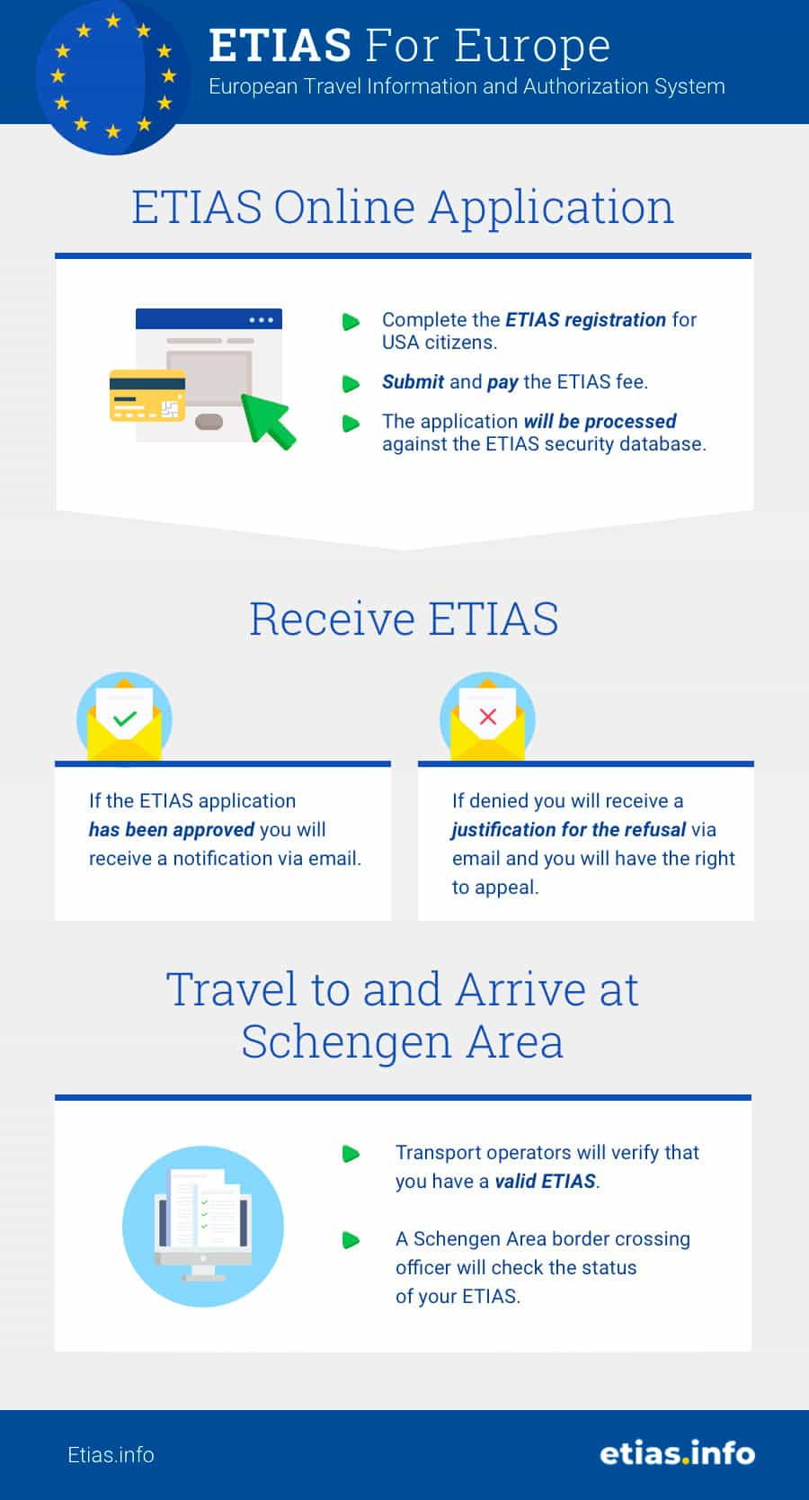

ETIAS Applications for U.S. Travelers:

You should apply at least 96 hours before departure. Because this is a new system, with likely glitches, recommend starting your application even earlier (See section below about whether you need confirmed travel plans before applying for the authorization).

Filling out the ETIAS application online is estimated to take about 10 minutes. Many travelers will receive a travel authorization “within minutes,” according to the ETIAS website. Once approved, an ETIAS travel authorization will be good for three years and can cover multiple trips.

You will need a valid passport, an email address, and a debit or approved credit card to pay the nonrefundable €7 (roughly $8) application fee. Children and teens under age 18 and seniors over age 70 will need to fill out an ETIAS application but will not be charged the fee.

Europe-bound airlines will be required by law to check passengers’ ETIAS authorizations before allowing them to board.

ETIAS eligibility requirements: To travel to Europe with ETIAS, you need to meet all the eligibility requirements:

You must be a national of a visa-exempt third country. There are more than 50 visa-exempt countries for the Schengen Area. You must be a citizen of one of these countries to apply for ETIAS.

Your passport must meet the validity requirements. Your passport must have been issued in the last 10 years by one of the countries eligible for ETIAS. It needs to be valid for at least 3 months after the date you’ll exit the Schengen Area.

You must be visiting Europe for a short-term. ETIAS is valid for short-term visits of up to 90 days per 180-day period. You can travel to Europe visa-free for tourism, business, and short study programs.

Are confirmed travel plans required to get an ETIAS?
Your travel plans do not need to be confirmed to apply for ETIAS.
You’re asked to state which Schengen country you’ll enter first when applying for your ETIAS. However, your plans can change once you have your approved ETIAS. Travel to any of the ETIAS countries with your travel authorization.
You’re not required to get a new ETIAS each time you visit Europe. ETIAS is a multiple-entry permit. Make sure your entire stay in the Schengen Area is within the 90-day per 180-day limit.
You need to reapply for ETIAS every 3 years, or when your passport expires (whichever comes first).

TRAVEL FORUM NOTES

_____________________________________________________________________________________________________________

______________________________________________________________________________________________________________

______________________________________________________________________________________________________________

______________________________________________________________________________________________________________

_______________________________________________________________________________________________________________

_______________________________________________________________________________________________________________

_______________________________________________________________________________________________________________

_______________________________________________________________________________________________________________

_______________________________________________________________________________________________________________

_______________________________________________________________________________________________________________

_______________________________________________________________________________________________________________

_______________________________________________________________________________________________________________

